**Homework 9**

**Machine Learning I: Supervised Methods**

**EE 559**

Shivans Amattya

5982564472

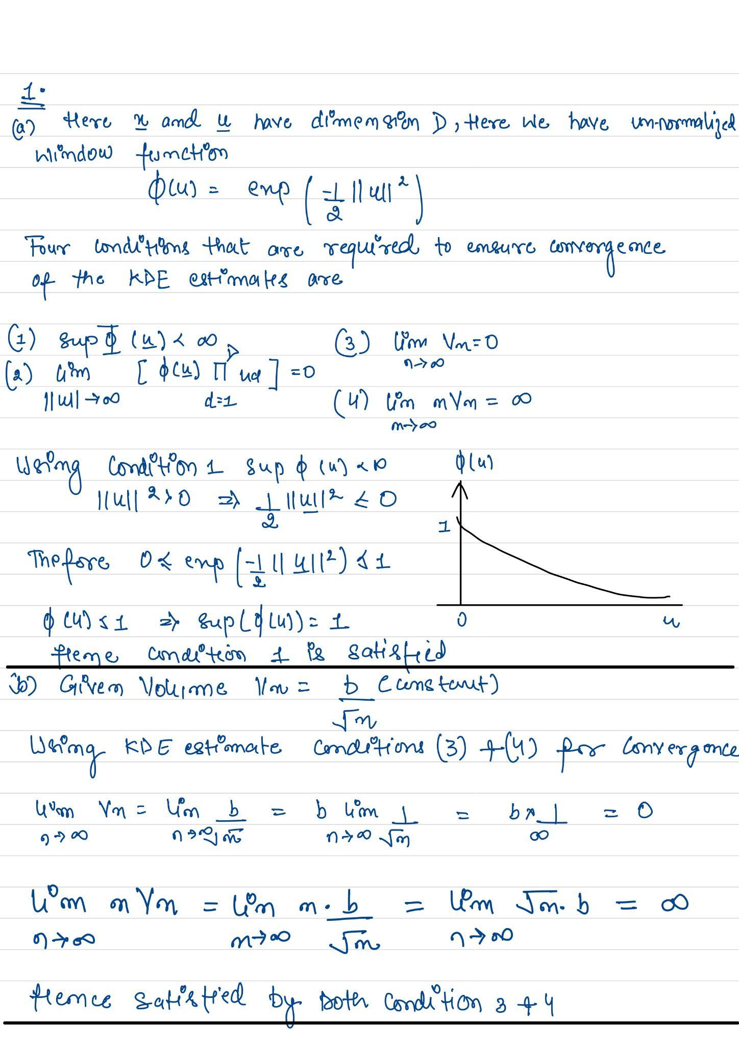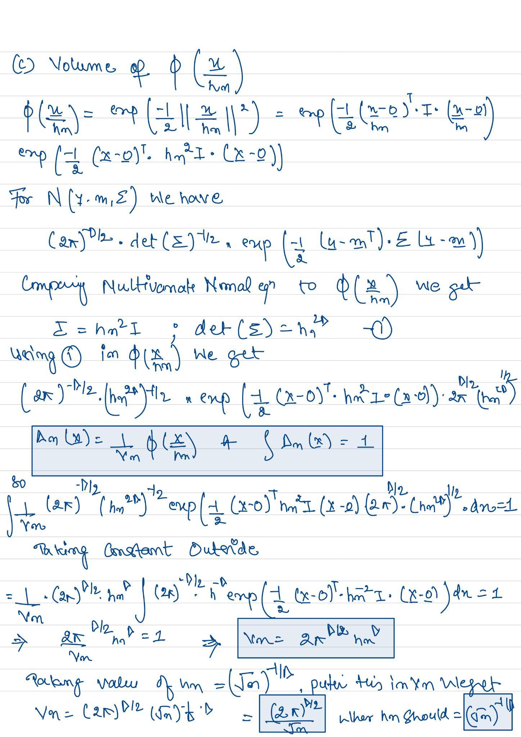

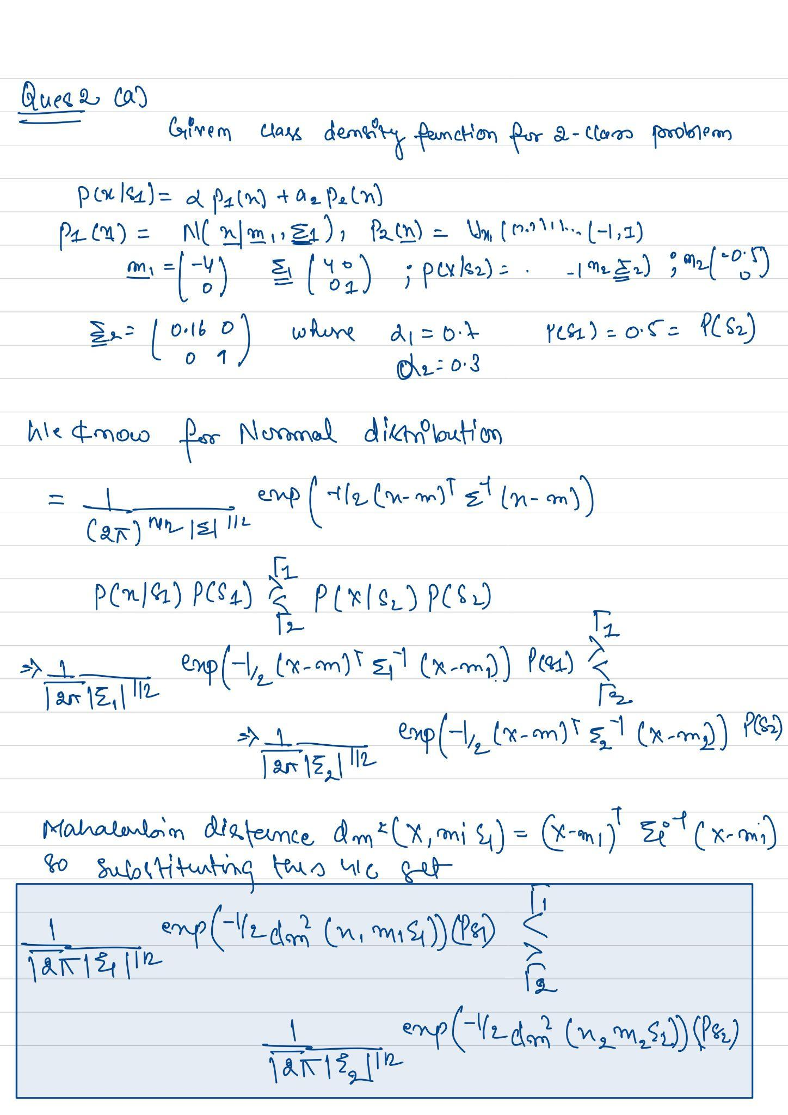

The decision boundary and regions, as well as the means of the three densities (2 means in S1, 1 mean in S2")

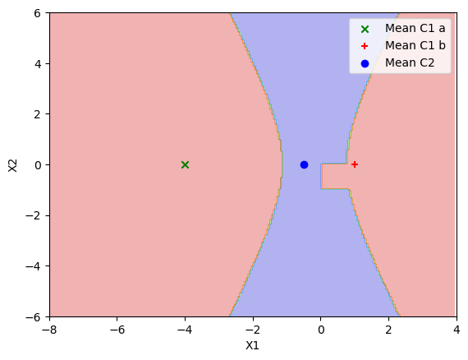

2b)

The scatter plot in 2D feature space of the first 2000 points in the full training set

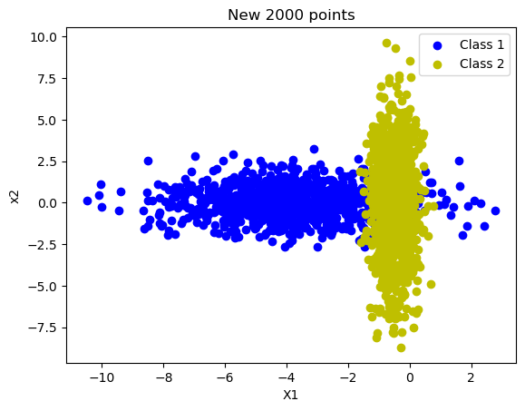

2c) The classification accuracy on the test dataset: 95.02

2d)

* Priors for n=200: [0.52, 0.48]
* Classification accuracy for n=200: 0.9482

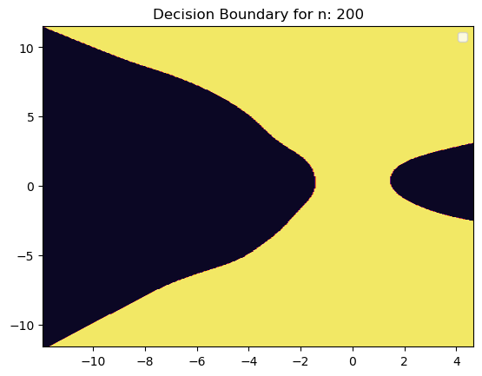

* Priors for n=2000: [0.4815, 0.5185]
* Classification accuracy for n=2000: 0.9549

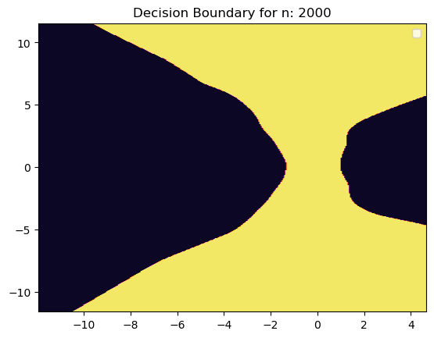

* Priors for n=20000: [0.4952, 0.5048]
* Classification accuracy for n=20000: 0.9561

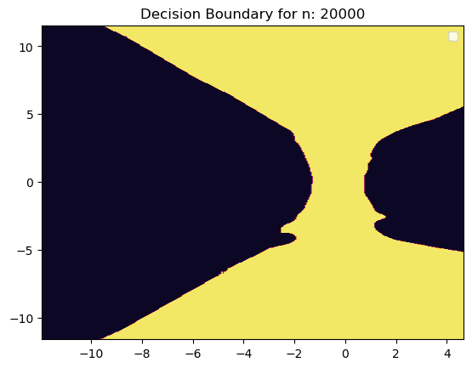

2e)

We see when KDE is implemented, the accuracy increases as the number of data points increases, and the decision boundary also becomes accurate with an increase in the number of data points, whereas, in part C, we get a classification accuracy for True Bayes minimum error classifier is 95.02, for N (the number of data points) was 2000, which was similar for KDE when the number of data points were 2000

i) The decision boundary also became accurate with an increase in the number of data points can verify as the decision boundary is wider for N=20000 when compared with N=200; also, we received similar priors for N=200 [0.52, 0.48],N=2000 [0.4815, 0.5185], N=20000: [0.4952, 0.5048] which are nearly identical with estimates of P(S1) and P(S2) it becomes more accurate and approach the true values of these probabilities.

ii) Yes, the error rates seem consistent with the plots because the law of large numbers states that as the sample size increases, the sample mean approaches the true means. The sample size is sufficiently large. The estimated probabilities become very close to the original probabilities. that is why, as the sample size increases from 200 to 2000 to 20000 became nearly identical to the original prior given for P(S1) and P(S2).